***Company Information***

| **Company Name** | *Electric Power Research Institute (EPRI)* | **Date Submitted** | *05/03/2021* |
| --- | --- | --- | --- |
| **Project Title** | *Encoding Manual Ultrasonic Testing in Industrial Nondestructive Evaluation*  **(EPRI_ULTRASONIC)** | **Planned Starting Semester** | *Fall 2021* |

**Number of Teams Requested to work on Project (check one):**

Single Team ($8,000) x Dual Team ($12,000)

**Faculty Mentor**

Faculty Mentor will be assigned to the project, unless you have already been working with a Faculty Mentor. If so, please specify the Faculty Mentor you have been working with, or mark “Please Assign”: ______Please Assign____________________

**Technical Contact(s)\***

| **Technical Contact** | **Name** | **Email** | **Phone** |
| --- | --- | --- | --- |
| **1** | Myles Dunlap | [mdunlap@epri.com](mailto:mdunlap@epri.com) | 704-595-2715 |
| **2** | Thomas Stafford | [tstafford@epri.com](mailto:tstafford@epri.com) | 704-595-2686 |
| **3** | Mark Dennis | [mdennis@epri.com](mailto:mdennis@epri.com) | 704-595-2648 |

*We would like to have more than one technical contact, so there is a back-up in case of travel, sickness, job re-assignment, etc. Also, these are the people that will have Event (Kick-off/Expo) invitations and name badges made for them, so please identify them to us so we can properly include them

**Financial Contact\*\***

| **Name** | Christina Kopitopualuo or Amy Vrabley |
| --- | --- |
| **Phone Number** |  |
| **Email Address** |  |
| **Billing Address** |  |

** This is the person that will receive and process the invoice

***Senior Design Project Description***

**Personnel**

Typical teams will have 4-6 students, with engineering disciplines assigned based on the anticipated Scope of the Project.

Please provide your estimate of staffing in the below table. The Senior Design Committee will adjust as appropriate based on scope and discipline skills:

| **Discipline** | **Number** | **Discipline** | **Number** |
| --- | --- | --- | --- |
| Mechanical | 1 | Electrical | 2 |
| Computer | 2 | Systems | 1 |
| Other ( ) |  |  |  |

**Company and Project Overview:**

The Electric Power Research Institute (EPRI) provides thought leadership, industry expertise, and collaborative value to help the electricity sector identify issues, technology gaps, and broader needs that can be addressed through effective research and development programs for the benefit of society. EPRI’s Nondestructive Evaluation (NDE) department is aiming to improve manual ultrasonic testing (UT) examination reliability through the use of innovative technologies that are easier to use, comparable to fully automated (i.e., robotic scanners), and able to provide an inspection record that easily facilitates independent review. In NDE a frequently used inspection method is UT and one purpose of the method is to inspect piping components for any type of flaws or discontinuities that would affect the health of the piping component.

In non-encoded UT, frequently referred to as manual UT within the nuclear industry, a human operator moves a handheld ultrasonic transducer across the surface of the component to be inspected. It requires only an examiner, a UT probe, and a UT instrument. It is easier to navigate in areas of limited access. Even though it is low cost and capable of inspecting broad areas, this approach does not typically generate computer-encoded images and supports mostly qualitative analysis during an inspection. While manual UT has been shown to be effective, it may result in false positives, conservative interpretations, and premature or unnecessary maintenance.

Figure 1 shows an image of a UT examiner in a nuclear power plant and they are performing a manual UT examination on a piping sample. A photograph of a typical UT probe is shown on the right-hand side of Figure 1 and the probe is being manually manipulated by the examiner as they move it along the circumference and axial locations around the pipe.

Figure 1  
(Left) An ultrasonic examiner performing a manual UT examination on a piping sample in a power plant. (Right) Ultrasonic probe that is being held in the hand of a UT examiner during an examination.

In the encoded method, a programmed robot often moves an ultrasonic device across the surface of the component to be inspected. It requires an operator(s), UT probe, instrument, robotic scanner, mounting device, and a computer. This method typically delivers the highest reliability and provides reviewable computer-encoded images. However, it may require more space to accommodate the additional equipment, and it is much more expensive than manual UT. The robotic scanner encodes the location of the UT probe relative to a defined origin on the piping component. The location of the UT probe is encoded in a grid pattern with typical resolutions of 1mm. Figure 2 shows a robotic scanner and grid pattern where each dot represents a point location on the pipe that UT data is collected.

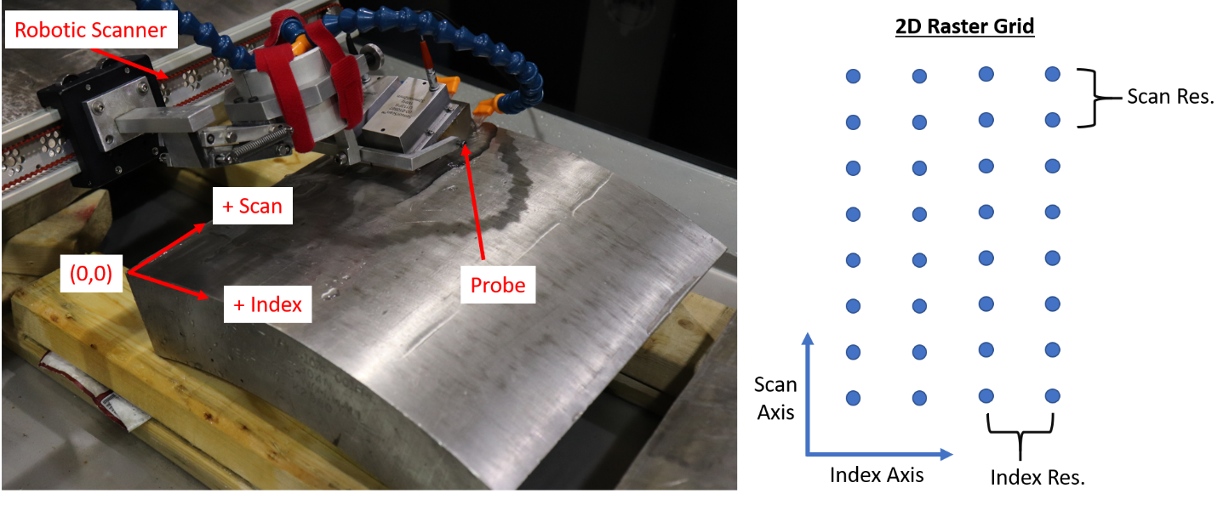

Figure 2  
(Left) Robotic scanner performing an encoded UT examination on a partial piping testing segment. (Right) UT data is collected in a grid pattern around the circumference of the pipe with typical resolutions of 1mm.

The objective of this project is to develop a low-cost and easy-to-use prototype system capable of performing encoded examinations on the outside surface while being manually held and manipulated by UT examiners. In other words, a prototype system will be demonstrated that can provide high resolution encoding in the circumferential and axial directions around a circular pipe while being manually held by an examiner. The prototype system will be encouraged to use minimal, to no, contact sensors capable of positional tracking such as motion sensor units, computer vision techniques, acruco markers, and other novel low-cost technologies. EPRI has performed research on this topic using Motion Sensor Units which were capable of encoding 1mm resolution around the circumference of piping components. An example of a EPRI’s motion sensor unit which is a low-cost, no contact, position tracking technology is show in Figure 3. Currently, the EPRI MSU is only capable of tracking circumferential position around the pipe and pipe must be oriented in a nearly horizontal position.

Figure 3  
EPRI Motion Sensor Unit shown on a UT probe as it tracks circumferential position around a pipe

In this project UNCC senior design students will develop creative and imaginative solutions that will expand this technology to meet the requirements set forth which will also track axial position along the pipe and be capable of handling different pipe orientations as well.

**Project Requirements:**

A richer description of the project requirements will be provided at the start of the project through EPRI staff and meetings; however, the following list does provide higher-level requirements.

* A prototype system will be demonstrated on representative piping samples such as PVC.
* UT probes and ultrasonic data will not be a focus during this study and therefore a dummy probe of a UT probe will be used as the object being tracked around the PVC pipe sample. The prototype system will need to capable of being connected to UT probes in an easy and quick manner. Specifications on a range of UT probe sizes and shapes will be provided to students.
* Ideally, the use and operation of the prototype system will need to be simple and usable – meaning that a new user could be trained on the use and operation of the prototype system in 30 minutes or less. Once an operator has been trained on the system it should take a user 10 minutes or less to setup the system on a piping component and begin their examination.
* An origin will be defined on the piping sample and it serves as the reference point for measuring the dummy probe’s axial and circumferential location.
* It is assumed a grid (either square or rectangular) will describe the points at which positional information for the dummy probe will be taken (refer to Figure 2).
* At each grid point the prototype system will need to output the positional information for the dummy probe and the output will be in a quadrature encoder format which can then be read into UT instruments.
* The assumed grid resolution will be as low as 1mm and it will need to work across an axial range of 0-200mm and the entire 360˚ circumference. This translates into a 1mm accuracy in both the circumferential and axial directions.
* The system will need to operate across pipe diameters ranging from 18-915mm. Testing will be demonstrated on pipe sizes of the following outside diameters: 101.6mm, 323.85mm, and 508mm.
* The prototype system will need to operate quickly enough to output positional information when the dummy probe is moved at a maximum velocity of 50 mm/sec.
* A program will be written to display the positional information in real-time and stored to a file.
* It is possible to have items mounted to a pipe that will assist in the tracking performance. However, it will be assumed that those items must be removed at the conclusion of an examination, they are accounted for in the setup time at the piping component (i.e., in 10 minutes or less), and also chemical and other restriction will apply.

**Expected Deliverables/Results:**

* Students will develop and present their design ideas to EPRI staff for review and selection.
* A prototype system will be demonstrated on representative piping samples such as PVC pipes of various diameters. Performance of the system will be evaluated against the technical requirements.
* Technical write-up on the prototype system describing all of it components and their integration.
* Source code and data analysis scripts will be provided to EPRI
* Technical presentation describing the system will be given to EPRI staff

**Disposition of Deliverables at the End of the Project:**

The prototype system and a technical write-up of the system would be demonstrated at the Expo and transitioned to EPRI after the conclusion of the Expo.

**List here any specific skills, requirements, specific courses, knowledge needed or suggested (If none please state none):**

* Design of Experiments ( SEGR 4141 for SE students)
* Circuits and Embedded Systems
* Programming and open source software
* Computer vision and image processing
* 3D Printing
* Data Analysis
* Human Factors Design for Usability
* Technical Writing and Presentations